Software Requirements Specification

For

System Cleaner

Version 1.0

Prepared by

Nishant Bhardwaj

MIET, Meerut

March 14, 2016

Table of Contents

1.0. Introduction 1

1.1. Purpose 1

1.2. Scope of Project 1

1.3. Glossary……………….....………………………………….2

1.4. Intended Audience and Reading Suggestions 3

2.0. Diagrammatic representation of software 4

2.1 Manual Process 5

2.2 General work flow of Proposed Software 6

2.3 Functional Requirements Specification 7

2.3.1 Use Case: System Cleaner 8

2.3.1.1 Use Case: Delete Log Files 8

2.3.1.2 Use Case: Delete Memory Dump Files 9

2.3.1.3 Use Case: Compress Old Files 12

3.0. Class Diagram.........................................................................16

4.0. Component Diagram 17

5.0. Requirements Specification 17

## 5.0.1 User Interface Requirements.............................................17

## 5.0.2 Software Interface Requirements......................................16

6.0. References 16

7.0. Conclusion 16

# 1.0. Introduction

## 1.1. Purpose

The purpose of this document is to present a detailed description of the System Cleaner. It will explain the purpose and features of the software, the interfaces of the software, what the software will do, the constraints under which it must operate and how the software will react to external stimuli. This document is intended for both the users and the developers of the system.

## 1.2. Scope of Project

System Cleaner is a standalone Java application that provides user with two options either to delete junk files or to purge old files.

Unlike other disk cleanup utilities our software will provide the user a one place solution for deleting and purging unwanted files

System Cleanup

Manual Automatic

Deletion Purging Deletion Purging

Goes to No Options File Type Specifies Drive Specific Drive . Delete Selected Identifies and Cleanup Utility files Purge Files

|  |  |
| --- | --- |
| **Term** | **Definition** |
| User | Person who owns or uses the System. |
| Temporary Windows Files | Files created by the system or application programs for a shorter time period. Usually have .temp extension and resides in the temp folder. (Path= "C:\Windows\Temp\") |
| Windows Log Files | Files created to record the activity of system. have .log extension |
| Temporary Internet Files | Files stored by the Web Browsers that allows websites to load more quickly the next time they are visited. These files serves as cache for the web browsers |
| Memory Dumps | Helps to recover from system crash |
| Empty Recycle Bin | Deleted files from system are still stored in the recycle bin.  Recycle Bin can be emptied to free up the space |
| Old Files | Files that has not been accessed from a long time. Such files can be compressed to save the disk space according to time period specified by user |

## 1.3. Glossary

***1.4. Intended Audience and Reading Suggestions***

This document is intended for any individual user, developer, tester, project manager or documentation writer that needs to understand the basic architecture and its specifications. Here are the potential uses for each one of the reader types:

1. **Developer**: The developer who wants to read, change, modify or add new requirements into the existing program, must firstly consult this document and update the requirements in appropriate manner.
2. **User**: The user of this program reviews the diagrams and the specifications presented in this document and determine if the software has all the suitable requirements and has been implemented well.
3. **Tester**: The tester needs this document to validate that the initial requirements of this programs actually corresponds to the executable program correctly.

# 2.0. Diagrammatic representation of software

SYSTEM CLEANER

Delete Temporary Windows Files

Delete log Files

Delete Temporary Internet Files

Delete Memory Dump Files

Empty Recycle Bin

Compress Old Files

## 

## 

Figure 1 – General Architecture of Software

## 

## 2.2 General work flow of Proposed Software

**Delete/Purge**

**Source Drive**

**Destination Drive**

**Time Period**

**Select File Type**

**Delete Selected Files**

**Archive**

**Filter According To File Type**

Figure 2 – General use case of proposed Software

This Software has one actor i.e. the system user. The user access the software through a simple and easy to use graphical user interface.

The software scans the complete system to search and clean the files specified by user.

## 2.3 Functional Requirements Specification

## 2.3.1 Use Case: System Cleaner

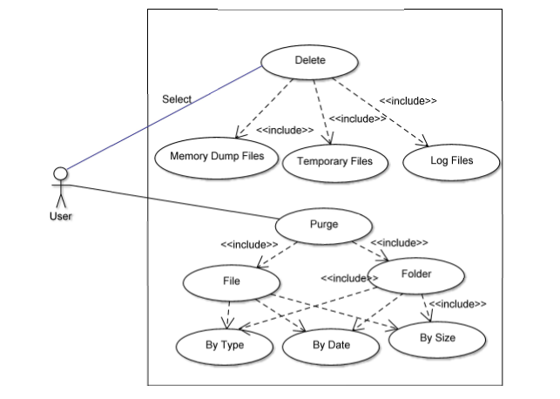

## 2.3.1.1 Use Case: Delete Log Files

**Diagram:**

System user

Delete log files

**Brief Description:**

The user selects to delete the log files from system.

**Initial Step-By-Step Description:**

Before this use case can be initiated, the user has already defined the Windows Operating System Version that is installed on the machine.

The user chooses to delete log files created by operating system and various other programs..

1. The user selects the delete log files option
2. The software scans the complete system to search for log files.
3. The software displays to user the details of all the log files found
4. The user confirms to delete all the log files.
5. The software delete all the log files found so far.

## 

## 2.3.1.2 Use Case: Delete Memory Dump Files

**Diagram:**

User

Delete Memory Dump Files

**Brief Description**

The User selects to delete memory dump files.

**Initial Step-By-Step Description**

Before this use case can be initiated, the user has already defined the windows operating system version installed on the machine.

1. The User selects to delete memory dump files.
2. The software scans complete system for memory dump files and show the complete details to the User.
3. The User confirms to delete files.
4. The software permanently deletes all Dump files.

## 2.3.1.3 Use Case: Compress Old Files

**Diagram:**

System user

Compress old files

**Brief Description:**

The user selects to compress old files on the basis of location and time period.

**Initial Step-By-Step Description:**

Before this use case can be initiated, the user has already defined the Windows Operating System Version that is installed on the machine. The user chooses to compress old files.

1. The user selects the compress files option
2. The software asks for drive containing old files.
3. The user identifies the files to be scanned.
4. The software asks for the period (days) after which files would be considered as old.
5. The user enters the period.
6. The software asks from the user for destination of compressed files.
7. The user specifies the location.
8. The software scans the specified location to identify old files.
9. The software displays to the user information about each old file identified.
10. The user confirms to compress the selected files.
11. The software compress the user confirmed files and stores them in destination.

# *3.0. Class Diagram*

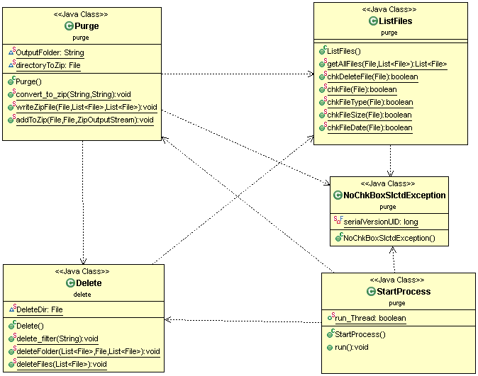

# *Component Diagram*

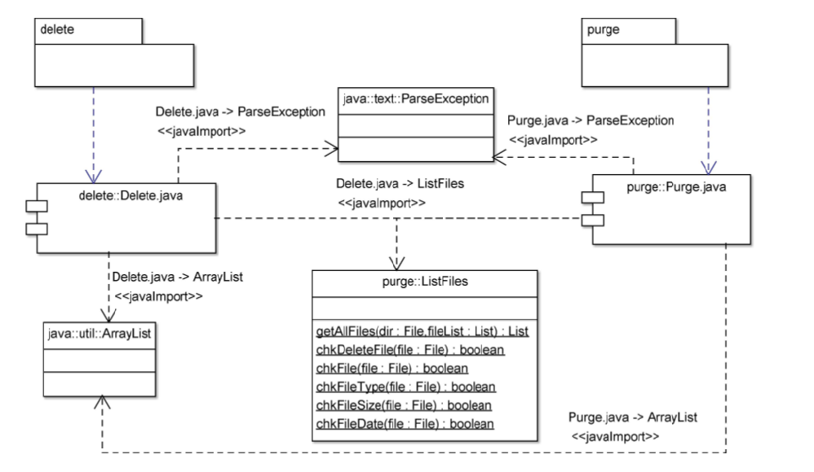

# *. Requirements Specification*

## 5.0.1 User Interface Requirements

* Easy to use and simple Graphical user Interface
* Complete Graphical Interaction
* Standard JAVA Swing Components

## 5.0.2 Software Interface Requirements

# Windows Operating System XP and later.

* JAVA Runtime Environment 6
* JAVA Swings

# *6.0. References*

* Wikipedia
* Microsoft

# *Conclusion*

Current software or utilities existing for windows cleanup such as disk cleanup does not provides the options of identifying old files.

They only delete the temporary/junk files and does not provide the facility to archive the files since it takes a huge amount of time to archive files.